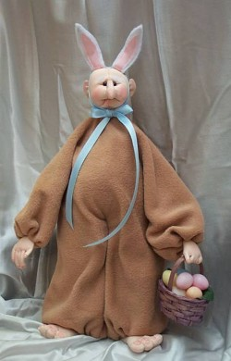
Bunny Man

Bunny Man made from
Meo Feroy's pattern, Gypsy George,
and the FREE patterns and instructions
for the costume, ears and feet found below.

Dollmaker’s Journey’s Site – Meo’s Patterns and More!
http://DollmakersJourney.com

Meo’s Pattern Site: http://www.stuffedmagic.com
Meo’s Ebay Page: http://members.ebay.com/aboutme/meomagic
